THE ALTERNATIVE TYPE OF LEES FILTRATION FOR SMALL AND MEDIUM-SIZED WINERIES
The time of grape harvesting is also a working point in cellar work. An elaborate and elementary process is the filtration of must and lees. Irrespective of the type of juice clarifying, a certain quantity of debris to be processed is produced. In addition to the objective of obtaining the clear juice from the lees, it is also about the profitability of the process. Apart from the time required, the necessary special filters and auxiliary equipment are associated with considerable investments. Susanne Winterling, Wein-und Sektgut Winterling in Niederkirchen, informs about an alternative in lees filtration.
A lot has to be considered when the conventional method of lees filtration by means of a chamber filter is carried out. The number of plates in the filter and the amount of addition of the filter aid perlite (cellulose, if any) are determined by means of the amount of debris. The purpose of this adjustment is to obtain the entire amount of debris through the filter and to obtain a dry cake as dry as possible on the plates without the latter being blocked before the end of the process and the remaining quantity of debris can no longer be filtered through these plates. Apart from the filtration process itself, the cleaning and maintenance of the filter is very time-intensive. The continuous process requires constant monitoring and binds a working person over a longer period of time.
Fig. 1: Bags filled with lees in the press
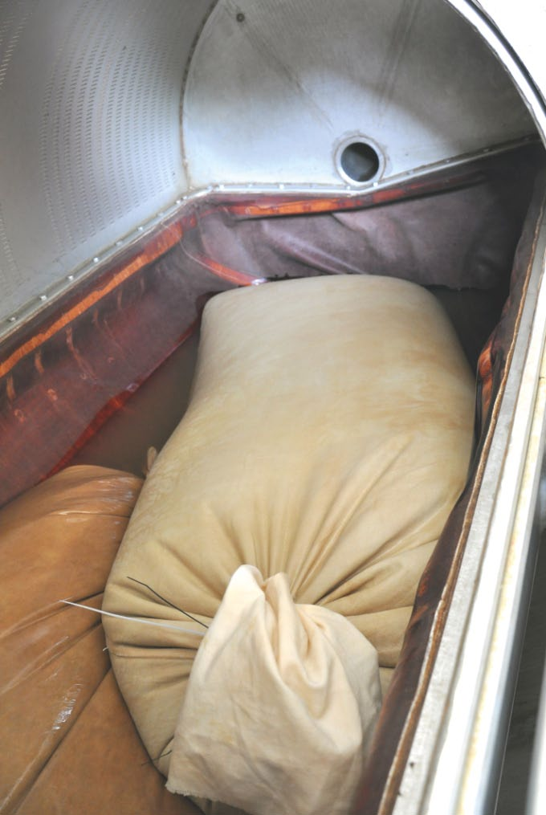
Therefore, consideration was given to alternatives to conventional lees filtration with a chamber filter press at the Sekt & Weingut Winterling (Niederkirchen, Palatinate, 11 ha) and Wengerter Winery (Erlenbach am Main, Franconia, 22 ha). These and corresponding experiments led to a further development of the “Trubsack” (lees bag) as it was already used in the past for yeast filtration. For several years now, the complete juice lees and wine yeasts have been filtered through the TRUBTUBE. In both wineries the experience shows that the use of the TRUBTUBE provides an absolute work relief and thus also a solution for lees filtration for owners of a pneumatic tank press.

Fig. 2: Filling the TRUBTUBE in the press
The workflow of the lees filtration with a filter bag is as follows: The lees are conveniently collected in a transportable container. In the past practice, 600L pallet containers were used, in which the lees volume can be easily read. 5 kgs of Perlite are added per 100L of lees volume. With very slimy lees, the amount should be increased. A slight sulfurization of the lees reduces the oxidation, or an early fermentation. The addition of a further 2 to 3 kg of cellulose accelerates the subsequent pressing of the liquid. Particularly with flotation lees, rapid processing should be taken into account, but sedimentation lees can still stand for several hours with appropriate sulfurization and then possibly be racked off before it is filled with perlite into the TRUBTUBE. The filtration bag itself consists of a special fiber. The special design of the seam and the special thread used give it great stability and long durability. With one filtration bag, approximately 250 liters of lees/yeasts can be processed in one operation.
The transport container with the lees-perlite-cellulose mixture is simply lifted over the wine press and filled there with the liquid. This is done without pumping, via a short hose, which opens into the TRUBTUBE. At least 40 cm of the bag should remain and should not be filled, in order to allow easy closure. This is done with a tear resistant cord and extra wide cable ties. In any case, the closure must be very stable in order to withstand the pressure in the wine press. Depending on the size of the pneumatic press, several bags can be placed in the press.

Fig. 3: Dry filter cake after pressing
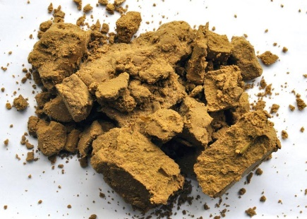
Thereafter, a pressure of at most 1.2 bar has to be setup and the press is subsequently switched off at this pressure. If the pressing pressure drops below 1.0 bar, what might happen with large amounts of debris, pressure has to be increased again. After about three hours (the lees can also be easily processed overnight), there is a nearly glossy light lees filtrate in the juice pan. As soon as no more juice drops from the press, the filtration is finished. The yield is almost 100%. The filter bag is also very suitable for the processing of complete small quantities, for example, berry extract or even ice wine, since it can be filtered almost without loss.

Fig. 4: Filtered juice drains into the juice pan
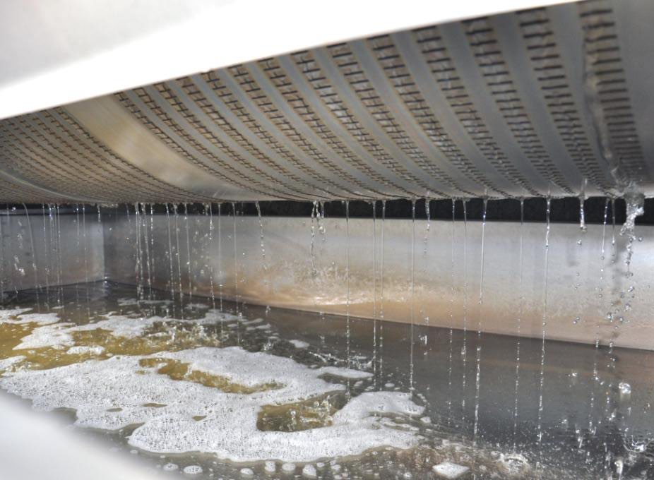
When no juice is dripping from the wine press, the pressure is released. The press basket is turned and the TRUBTUBE is brought out of the wine press with the dry lees/yeast residues. After emptying it, it is turned over and placed in the empty juice pan of the wine press and sprayed with water (DON’T use a high-pressure washer as this might destroy the fabric). After this cleaning, the bag is ready for the next application. If the TRUBTUBE is not used during the season, it should be stored in a lightly sulphured citric acid solution. If the juice flow becomes slower after several operations, the bag can be washed with a commercially available filter cloth cleaner. Washing with caustic soda and subsequent neutralization with citric acid is also possible, the tissue is not attacked by it. After the season, the cleaned bag is dried in the air and stored in air-tight packaging until the next use. The mentioned applications were tested only on pneumatic presses of the brands "Europress" and "Willmes". Spindle presses and other pressing systems with internal logging devices (chains, rings or similar) are not suitable for filtration with the TRUBTUBE.

CONCLUSION
TRUBTUBE bags are practical and, above all, very hygienic filters, which optimally integrate into the working process during harvest and racking season. Even with an operational size of 1,200 cs, the complete lees can be clarified over the filter bag.

Exclusive Distribution in Canada by:

